

To: Professor Pisano

From: Aidan, McCall, Jonas Escobar

Team: Smart Grid (30)

Date: 03/10/22

Subject: 2nd Prototype Testing

1. **Materials Required**

Hardware

* Smart Grid Test Facility
* DC Power Supply (3.3V, 5V)
* Oscilloscope
* Picoscope
* NI myDAQ
* Banana cables/BNC-Alligator probes

Software

* MATLAB
* MATLAB Signal Processing packages
* Proper daq driver softwares
  + NI DAQ mx Elvis/driver software
  + MATLAB Data Acquisition Toolbox
  + MATLAB Data Acquisition Toolbox Support Package for NI-DAQmx Devices
* Data collection scripts

**2.0 Setup**

2.1 Preparing the model for operation

1. Plug the power strip into the wall. Though the presence of a benchtop power supply is a current design flaw (we would like to find a solution for easier transport), we are still using it to power the control boards (MSP430s) for now.
2. Before connecting the model, the 6V output is set to 3.3V, and the +25V output is set to 5V, and both sides are grounded. With the output turned off, we wire the leads to the corresponding inputs on the outside of the model.
3. Turn on the oscilloscope and wire the leads to points 1 and 3, according to Figure 1.

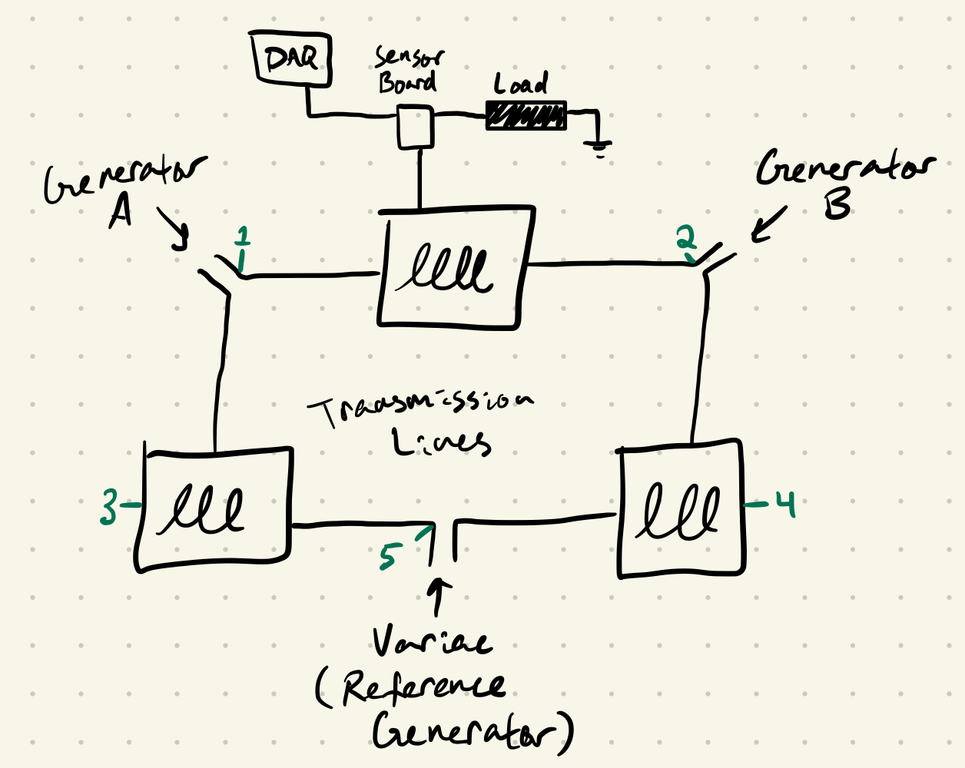

*Figure 1: Basic schematic of the grid*

1. All the hardware is set, so turn on the output of the benchtop power supply, in order to let the microcontrollers settle.
2. Then turn on the main switch on top, labeled 24V, to bring power to the rest of the model
3. The variac/reference generator is turned on after. The reference waveform should be visible on the oscilloscope (from point 3), at 60Hz and 24Vpp.

2.2 Setting up the Picoscope

1. Plug the picoscope into a computer.
2. Attach the probes to point 2 (Channel 1) and point 4 (Channel 2).
3. Pulling up the PicoScope 6 application should bring up a live feed with the 60 Hz, 24Vpp wave being visible on the computer.

2.3 Activating the generators and synchronizing

1. To turn on a generator, we reset the microcontroller by pressing the button labeled by an arrow for the MSP430 corresponding to that generator. When the button for A is pressed, the generator will begin its rotation and it should now be visible on the oscilloscope (from point 1). Their peak-to-peak voltage should be close to the same.
2. Next, flip the slide switch on the synchronization circuit for A to the green/on position, which will give additional feedback via the LED. The LED will flicker on and off due to the phase differences between the reference generator and the signal produced by generator A; the two signals are in phase when the LED is dim, and out of phase when it is lit up (i.e. out of phase means there will be a voltage difference across the diode causing it to be lit).
3. The toggle switch (with on/off labels) should be closed (switched to on) at a moment when the two waves are in phase.
4. Closing this will short circuit the two nodes we’re measuring on the oscilloscope, so the probe at point 3 should be moved to point 5 to compare generator A to the reference. This way we can check that the peak-to-peak voltage is remaining constant, and if it’s not then the main 24V switch should be switched off, along with the variac, to reset the model and start over. In theory, the frequency of generator A should also stabilize to 60Hz, but we’re not currently seeing this behavior.
5. These steps will be repeated for generator B, using the PicoScope to view the waveforms. After closing the toggle switch, generator B should then be compared to either generator A or the reference generator. If voltages are remaining constant, then the grid is running properly. We plan to measure A synchronization on the oscilloscope and B synchronization on the picoscope.

**3.0 Detailed Measurements Taken**

3.1 Picoscope Data Analysis

From the Picoscope, we observed live data (seen in Figure 2.) in order to synchronize the generator B to the reference. After saving a CSV. file to MATLAB. We ran a Matlab script, which outputs the data shown in Figure 3,4, and 5. This includes frequency response of the waveforms to assure the frequency is in the range of 60 Hz, the voltage waveform showing the waves synchronized and unsynchronized, and an output of Vpp for each waveform, which amounts to about 24 V (16.97 Vrms). These figures can be used to visually display the synchronization process, while outputting the frequency and voltage data that confirms the correct values.

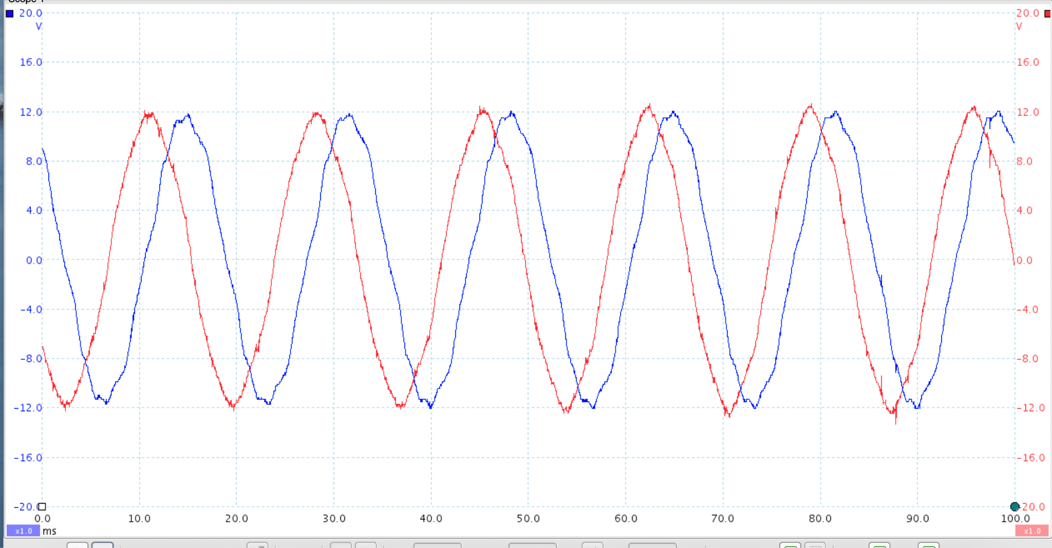

*Figure 2: Live Data from the Picoscope with the probes attached to point 2 (Channel 1: blue) and point 4 (Channel 2: red) from Figure 1 as defined in the setup.*

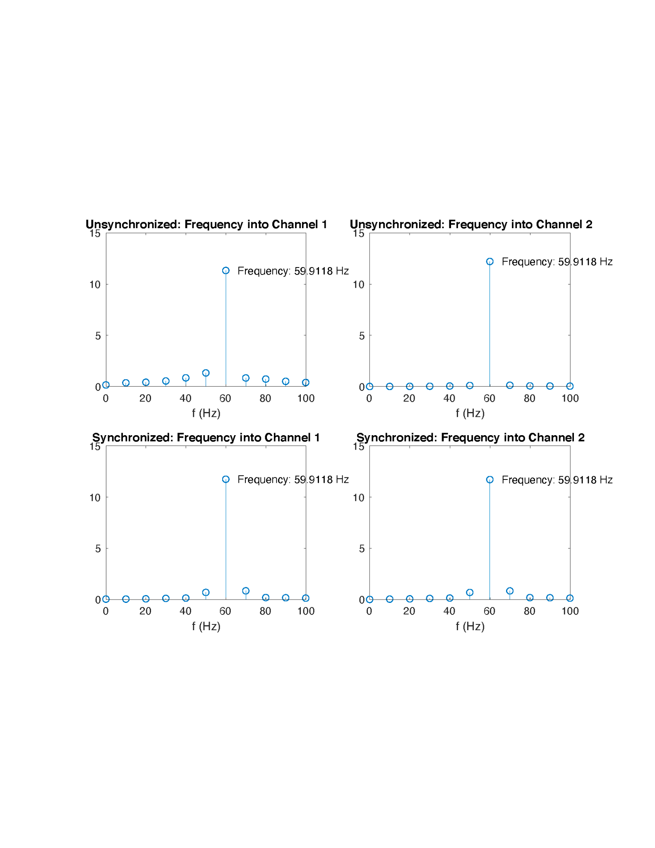

*Figure 3: The frequency response for each channel's waveform before and after synchronization*



*Figure 4: The average peak-to-peak voltage before and after synchronization*

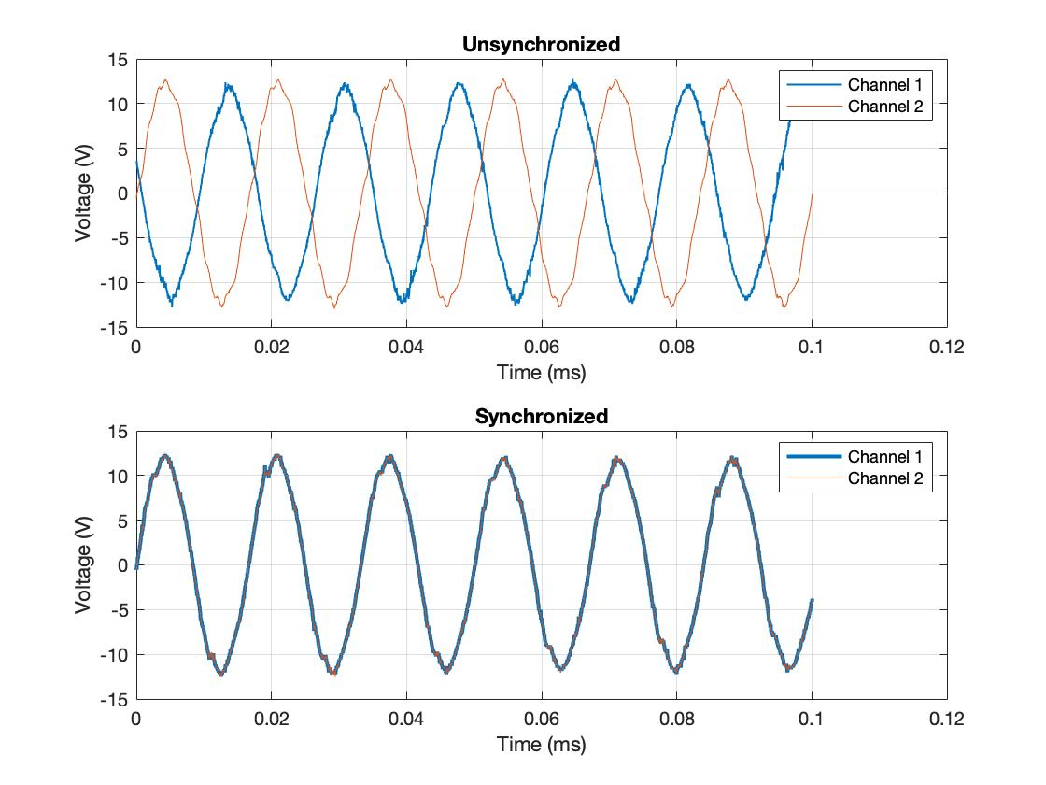

*Figure 5: Data plotted which visually shows the two channels before and after synchronization.*

3.2 Collecting data from the DAQ

Next, we added loads to the system. To test the DAQ, we ran the prepared MATLAB script, and saw how the data was different for each type of load. For the inductive load, the current and voltage are more out of phase than the resistive load, which makes sense for the phasers.

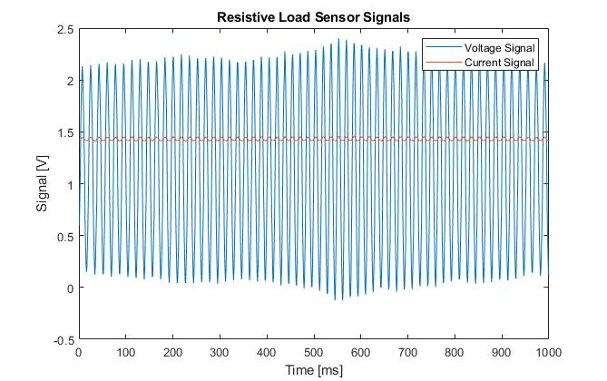

*Figure 6: Waveform recorded by DAQ with “Load” of Figure 1 entirely resistive.*

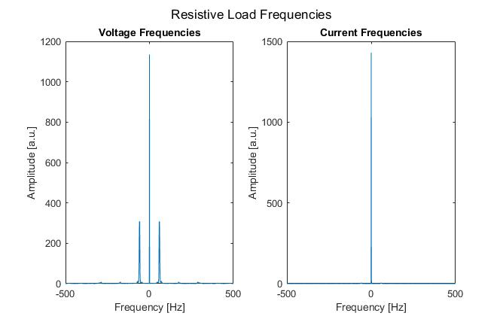

*Figure 7: Frequencies corresponding to waveforms in Figure 6.*

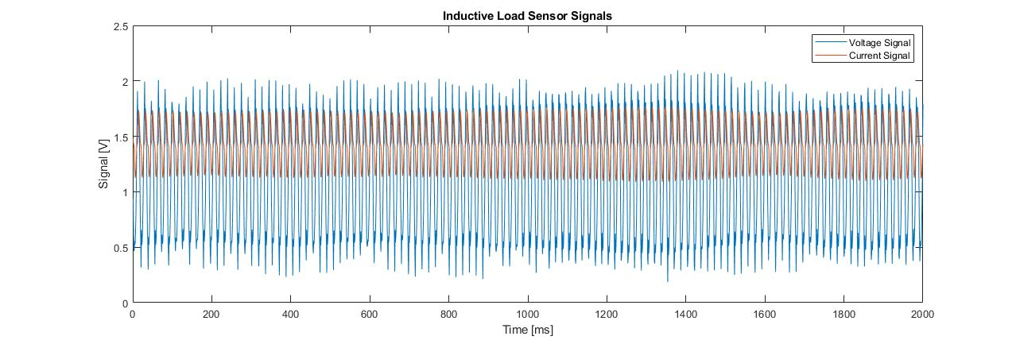

*Figure 8: Waveforms acquired from DAQ with load entirely inductive.*

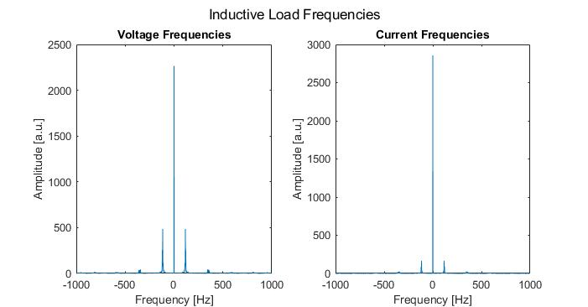

*Figure 9: Frequencies corresponding to waveforms in Figure 8.*

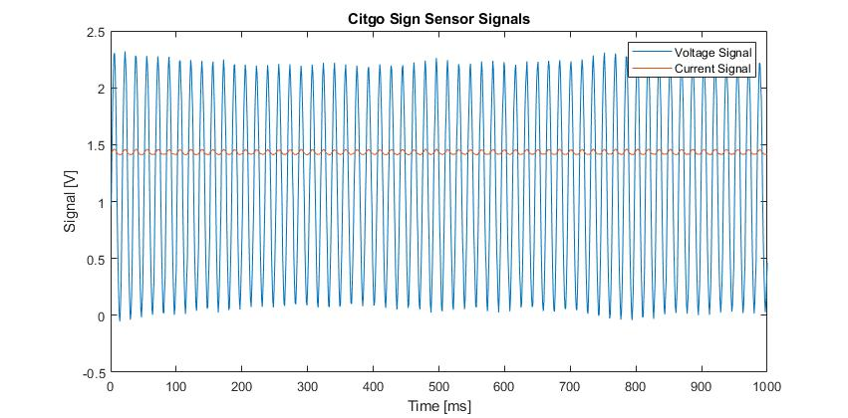

*Figure 10: Waveforms acquired from DAQ with a scale Citgo Sign as the load. (Resistive with diodes).*

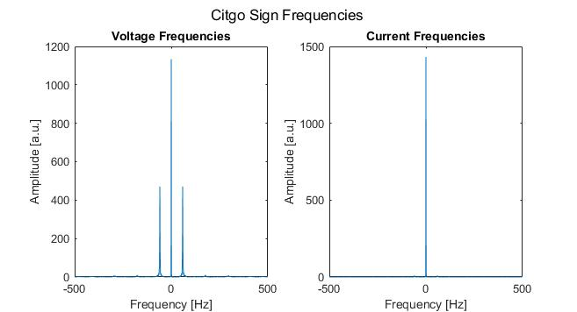

*Figure 11: Frequencies corresponding to waveforms in Figure 10.*

**4.0 Conclusion**

Success for this prototype testing was measured by the following criteria:

1. Successfully start the grid with both generators synchronized and connected to the grid
   1. Synchronization means the 2 generators are connected to the grid and no major changes in frequency and Vpp are observed. Note: synchronization does not mean all three generators will be in phase.
2. Successfully connect the picoscope to the grid, and observe the live feed, using it to synchronize generator B.
3. Successfully download a .CSV file from the picoscope and run the MATLAB script on the data collected.
   1. The MATLAB script should output frequencies of 60 Hz +/- 10 Hz, and peak to peak voltages of 24 Vpp +/- 5V.
4. Successfully connect and collect data from the DAQ, understand what the data is showing about the loads inserted to the grid.

All criteria were successfully met during prototype testing as seen in Section 3.0 of this report. Based on test data, the grid is working as expected. The grid is outputting a 24 Vpp, 60 Hz waveform and our instrumentation is properly collecting data. When the resistor is used as the load, we observe no phase shift between the load voltage and current. When the inductors are used, we observe a phase shift between the load voltage and current. Of course, we still have some improvements to make, including building the UI itself for control of the DAQ and data processing. This prototype testing was mainly to test the setup of the model and its operation, as well as the core instrumentation and basic data processing in MATLAB. While the picoscope data was not yet collected in MATLAB, our fundamental system is ready and we plan to bring all of these pieces together in a first draft of the UI, which we can then review with the client for suggestions on additional useful data points.